
“CUSTOMER SEGMENTATION ANALYSIS FOR IMPROVING SALES USING CLUSTERING”
Mini Project report Submitted in partial fulfillment of the requirements for the award of degree of Bachelor of Technology in
CSE - Cyber Security
by
M. Sanjana (21P71A6264)
N. Sangeetha (21P71A6263)
V. Sreeja (21P71A6287)
Varun Singh Thakur (21P71A6296)
Under the Esteemed Guidance of
Mrs. V. Sai Lavanya
(Assistant Professor)
Department of CSE (CYBER SECURITY)

(Affiliated to JNTU-H)
2021-2025


DEPARTMENT OF CSE(CYBER SECURITY)
CERTIFICATE
This is to certify that the project report entitled “CUSTOMER SEGMENTATION ANALYSIS FOR IMPROVING SALES USING CLUSTERING” is being submitted by M. SANJANA (21P71A6264), N. SANGEETHA (21P71A6263), V. SREEJA (21P71A6287) VARUN SINGH THAKUR (21P71A6296) in partial fulfillment for the award of Degree of BACHELOR OF TECHNOLOGY in CSE (CYBER SECURITY) to the Jawaharlal Nehru Technological University is a record of bonafide work carried out by him/her under my guidance and supervision.
Date :

Internal Guide

HOD-CS

External Examiner Principal

ACKNOWLEDGEMENT
First of all, we thank our project guide Mrs. V . Sai Lavanya, Assistant Professor, and HOD
Mrs. Ch. Hyma the Department of CSE-Cyber Security for giving us this opportunity in
developing this project. This project has really helped us in enhancing our skills of programming,
the perspective with which we should view projects and above all, our presentation and
interpersonal skills. Last but not the least, we also thank the professors of our department for
lending their helping hand whenever it was necessary.

M. SANJANA
(21P71A6264)

N. SANGEETHA
(21P71A6263)

V. SREEJA
(21P71A6287)

VARUN SINGH THAKUR
(21P71A6296)

DECLARATION
We hereby declare that the work which is being presented in this Mini Project entitled, “CUSTOMER SEGMENTATION ANALYSIS FOR IMPROVING SALES USING CLUSTERING” submitted to JNTU-H, in the partial fulfillment of the requirements for the award of the degree of BACHELOR OF TECHNOLOGY in CSE - CYBER SECURITY, is an authentic record of my own work carried out from September 2024 to January 2025 under the supervision of Mrs. Sai Lavanya, Assistant Professor, CS Dept., SVIT, Mahbub Campus. The matter embodied in this project report has not been submitted by us for the award of any other degree.

Place: SECUNDERABAD
Date:

M. Sanjana
(21P71A6264)

N. Sangeetha
(21P71A6263)

V. Sreeja
(21P71A6287)

Varun Singh Thakur
(21P71A6296)

Table of Contents

ABSTRACT 9
1.INTRODUCTION 10
1.1 Motivation: 10
1.2 Problem Definition: 10
1.3 Objectives: 11
1.4 Scope of the project: 12
2. LITERATURE SURVEY 13
2.1 Introduction: 13
2.2 Existing System: 13
3.ANALYSIS 14
3.1 Hardware requirements: 14
3.2 Software requirements: 14
3.3 System architecture: 14
4. SYSTEM DESIGN 16
4.1 Introduction : 16
4.2 UML Diagrams 16
4.2.1 Use Case Diagram 17
4.2.2 Class Diagram 18
4.2.3 Sequence Diagram 19
4.2.4 Activity Diagram 20
5.IMPLEMENTATION AND RESULTS 22
5.1 Introduction 22
5.2 Technologies Used 22
5.3 Modules Used 22
5.3.1Data Analysis and Data Preprocessing: 22
5.3.2 Model Development: 23
5.3.3 Model deployment : 23
5.3.4 Data Visualisation : 23
5.4 Source Code: 23
5.5 OUTPUT SCREENS: 36
6.TESTING AND VALIDATION 41
6.1 Introduction 41
6.2 Types of Tests 42
Functional Testing: 42
Usability Testing: 43
Performance Testing: 43
Security Testing: 44
Compatibility Testing: 44
Regression Testing: 45
Smoke Testing: 45
Localization and Internationalization Testing: 45
Recovery Testing: 46
6.3 Test Strategy and Approach 46
6.4 Test Results and Defect Management 46
6.5 Acceptance Testing: 48
6.6 Performance Testing 48
7.FUTURE ENHANCEMENTS 50
8. REFERENCE 52

ABSTRACT

Customer segmentation is useful in understanding what demographic and psychographic sub-population there are within your customers in a business case. By understanding this, we can better understand how to market and serve them. The segmentation is based on customers having similar ‘needs’(so that a single whole product can satisfy them) and ‘buying characteristics’(responses to messaging, marketing channels, and sales channels, that a single go- to-market approach can be used to sell to them competitively and economically). In this project we will explore a data set on customers to try to see if there are any discernible segments and patterns.The goal of segmenting customers is to decide how to relate to customers in each segment in order to maximize the value of each customer to the business and to build a simple, easy to use and efficient interface. The technologies that will be used in this project are packages such as numpy, panda, seaborn and matplotlib. Tools such as jupyter notebook will be used to analyze and segment each individual customer. Segmentation will be based on three important attributes : ‘gender’, ‘income’ , ‘age’ and ‘spending score’

INTRODUCTION

1.1 Motivation:
Customer segmentation using clustering techniques is a powerful approach to improving sales by identifying distinct groups of customers based on their behaviors, preferences, and demographics. The motivation behind applying clustering methods lies in their ability to help businesses create personalized marketing strategies, optimize resource allocation, and enhance customer retention. By analyzing customer data such as purchase history, demographics, and engagement patterns, businesses can uncover hidden patterns and group similar customers into clusters. Popular clustering techniques like K-Means, Hierarchical Clustering, and DBSCAN allow companies to segment customers based on spending habits, frequency of purchases, and product preferences. This segmentation enables businesses to tailor their marketing efforts, offer targeted promotions, and improve customer experiences. For instance, high-value customers can be offered loyalty rewards, while budget-conscious customers can receive special discounts. The process involves data collection, preprocessing, applying clustering algorithms, and deriving actionable insights that can drive business growth. By continuously monitoring and refining these clusters, businesses can stay aligned with evolving customer needs and market trends, ultimately leading to increased sales and customer satisfaction.

1.2 Problem Definition:
Identification of Customer Groups: Clustering algorithms (e.g., K-Means, hierarchical clustering, DBSCAN) group customers with similar behaviors and characteristics.
Personalized Marketing: Enables targeted promotions and personalized recommendations based on customer preferences.
Improved Customer Engagement: Tailoring communication strategies to different segments enhances customer satisfaction and loyalty.
Sales Optimization: Helps identify high-value customers and create specialized offers to maximize revenue.
Resource Allocation: Focuses marketing and sales efforts on the most profitable customer segments, improving ROI.
Behavioral Insights: Provides deeper understanding of purchasing patterns, preferences, and trends.
Product Development: Insights from segmentation can guide new product offerings aligned with customer needs.
Churn Reduction: Identifies at-risk customers for proactive engagement to prevent churn.
Pricing Strategies: Enables dynamic pricing models tailored to different customer segments.
Data-Driven Decision Making: Enhances business strategies with actionable insights from customer data analysis.
Using clustering for customer segmentation leads to more effective sales strategies, better customer relationships, and overall business growth.

1.3 Objectives:

Identify Distinct Customer Groups: Group customers based on similar behaviors, preferences, or demographics to understand their unique needs.
Enhance Marketing Strategies: Develop targeted marketing campaigns for each segment to improve engagement and conversion rates.
Increase Customer Retention: Identify loyal customers and at-risk segments to implement retention strategies and reduce churn.
Optimize Product Offerings: Align products and services with the preferences of specific customer groups to maximize satisfaction and sales.
Improve Pricing Strategies: Customize pricing models based on customer segments to enhance profitability and competitiveness.
Efficient Resource Allocation: Focus sales and marketing efforts on the most profitable customer segments to maximize return on investment (ROI).
Enhance Customer Experience: Personalize interactions and offers to meet the expectations of different customer groups.
Identify New Market Opportunities: Discover underserved or emerging segments to expand market reach and drive growth.
Boost Cross-Selling and Upselling: Leverage segmentation insights to recommend relevant products and increase revenue per customer.
Support Data-Driven Decision Making: Use clustering analysis to provide actionable insights for strategic business planning and growth.
These objectives help businesses better understand their customers, leading to more effective sales strategies and improved business performance.

1.4 Scope of the project:
The scope of the project on Customer Segmentation Analysis for Improving Sales Using Clustering encompasses identifying meaningful customer groups to enhance business strategies and drive revenue growth. By analyzing customer data such as demographics, purchasing behavior, and engagement patterns, the project aims to create actionable insights that enable businesses to personalize their offerings. This segmentation allows companies to tailor marketing campaigns, optimize resource allocation, and design targeted loyalty programs to meet the unique needs of each segment. The project involves applying clustering techniques like K-Means or Hierarchical Clustering to identify distinct customer groups, ensuring that the segmentation is both meaningful and actionable. Additionally, the scope includes evaluating the effectiveness of the segmentation by assessing its impact on sales, customer retention, and overall business growth. This project has applications across industries, helping businesses improve customer satisfaction, increase profitability, and gain a competitive advantage in the market.

2. LITERATURE SURVEY

2.1 Introduction:
- Effective body language enhances your message, making it more Customer segmentation is the practice of dividing a company’s customers into groups that reflect similarity among customers in each group.
- The goal of segmenting customers is to decide how to relate to customers in each segment in order to maximize the value of each customer to the business.
- Customer segmentation has the potential to allow marketers to address each customer in the most effective way.
- Packages: NumPy, pandas, seaborn and matplotlib
- Tools such as jupyter notebook to analyze and segment each individual customer.
- It is based on four important attributes i.e. ‘age’, ‘gender’, ‘income’, and ‘spending score’.

2.2 Existing System:
- All the existing systems use search-based algorithms like fuzzy C-means, Gath Geva algorithm and Two step algorithm.
- With these algorithms it is difficult to gather and segment the data.
- The results are not really accurate as the clustering is not close enough to determine accurate centroids
- These algorithms are complicated when compared to K-means Clustering.
- Existing Systems Using K-Means: Retail and E-Commerce: Online retailers often use K-Means to segment customers based on purchasing behavior (frequency, recency, and monetary value). These segments are then targeted with personalized product recommendations or promotional discounts.

3.ANALYSIS

3.1 Hardware requirements:
- Hard disk
- System (8GB RAM and 1TB Hard Disk)
- Forms (To collect data from the customer in malls)

3.2 Software requirements:
- Operating system (Windows 10)
- Anaconda
- Jupyter
- Kaggle

3.3 System architecture:
- The machine learning architecture defines the various layers involved in the machine
- learning cycle and involves the major steps being carried out in the transformation of raw data into training data sets capable for enabling the decision making of a system.
- It begins with gathering data from various sources, including customer demographics, behavioral patterns, transactional histories, and third-party information. This data is stored in relational databases, NoSQL databases, data warehouses, or data lakes, depending on its structure and volume.
- The next step involves processing the data through cleaning, transformation, and feature engineering to prepare it for analysis.
- Advanced analytics techniques, such as clustering (e.g., K-Means) and supervised learning (e.g., Random Forest), are applied to identify distinct customer segments. Dimensionality reduction methods like PCA are used to simplify data when needed.
- The segmentation results are visualized using tools like Tableau or Power BI to provide actionable insights, such as identifying high-value customer groups or predicting churn.
- These insights are then integrated into business applications like CRM systems for personalized marketing, product recommendations, and customer retention strategies.
- Continuous monitoring and feedback loops ensure the models remain effective, incorporating updated data and A/B testing to refine segmentation strategies over time.
- This robust architecture enables businesses to make data-driven decisions and optimize customer engagement.

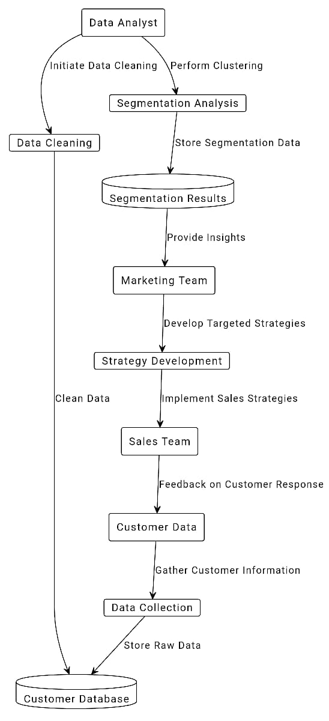
Figure 3.3 : Architecture

4. SYSTEM DESIGN

4.1 Introduction :
The Customer Segmentation Tool is an interactive and user-friendly web application designed to empower businesses and analysts to gain insights into customer behavior. By leveraging machine learning techniques, the tool categorizes customers into distinct groups based on their spending habits and income levels, enabling businesses to develop targeted marketing strategies and improve customer engagement.
Businesses today are inundated with vast amounts of customer data, and the ability to derive actionable insights from this data is critical for informed decision-making. By utilizing advanced data visualization and clustering techniques, this tool empowers businesses to segment their customers into distinct groups based on behavioral and demographic attributes, such as age, income, and spending habits.
This tool is built using modern data science and machine learning frameworks and is wrapped in an intuitive web-based interface for accessibility. It caters to business professionals, data analysts, and students aiming to explore customer segmentation concepts without requiring advanced technical expertise.

4.2 UML Diagrams
Unified Modeling Language (UML) is a standardized visual language used to model the structure and behavior of software systems. It provides a set of diagramming tools to design and represent complex systems clearly and concisely. UML is widely used for system architecture, business process modeling, and software development, enabling teams to visualize workflows, relationships, and system interactions. By offering diagrams like use case, class, activity, and sequence diagrams, UML ensures that developers, analysts, and stakeholders have a shared understanding of the system design, making it an essential tool for planning, communication, and documentation.
The design incorporates Unified Modeling Language (UML) diagrams such as Use Case, Activity, and Sequence diagrams to represent different aspects of the system. These diagrams help in understanding the functional and behavioral aspects of the clustering-based segmentation process.
The primary goal of the system design is to ensure the efficient and seamless implementation of customer segmentation for improved sales strategies.

4.2.1 Use Case Diagram
The Use Case Diagram is used to identify the key actors and use cases involved in the system. The actors represent entities that interact with the system, while the use cases define the system's functional requirements.
Actors:
Admin/User: Uploads customer data, configures clustering parameters, and reviews segmentation results.
System: Processes data, performs clustering, and generates insights.
Use Cases:
Upload customer data.
Perform data preprocessing.
Apply clustering algorithm.
Visualize clustering results.
Generate actionable insights.
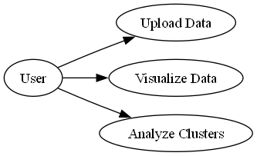
Figure 4.2.1: Use Case Diagram

4.2.2 Class Diagram

The diagram represents a class diagram that shows the relationships between three components: StreamlitApp, Data, and Graphs.
Components:
StreamlitApp: This is the main application framework, likely built using Streamlit, which is a Python-based framework for creating interactive web applications.
Acts as the controller that coordinates the interaction between the Data and Graphs components.
Responsibilities: Collects user inputs. Manages workflows (data handling and visualization).
Data: Represents the dataset or information processed within the application.
Handles: Loading datasets. Cleaning or preprocessing data. Providing the processed data for further visualization or analysis.
Interaction: The StreamlitApp interacts with the Data class to perform data-related operations.
Graphs: Represents the visualization module of the system.
Responsibilities: Takes the processed data from the Data component. Generates visualizations like charts, graphs, or other graphical representations.
Interaction: The StreamlitApp interacts with the Graphs class to initiate graph generation based on user inputs and processed data.
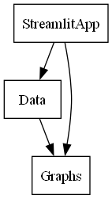
Figure 4.2.2: Class Diagram

4.2.3 Sequence Diagram
The Sequence Diagram captures the interaction between different components of the system, illustrating the order in which tasks are performed.
Objects:
Admin/User: Triggers system actions.
System: Processes data, applies clustering, and generates outputs.
Visualization Module: Displays segmentation results.
Sequence of Interactions:
The admin uploads the dataset to the system.
The system preprocesses the data.
The clustering algorithm is executed.
The results are sent to the visualization module.
The admin reviews the insights.
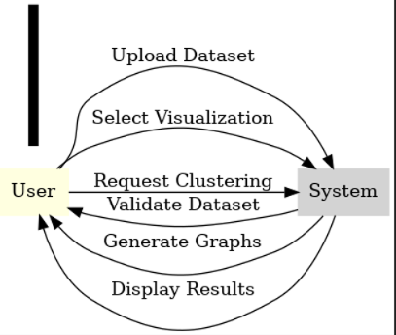
Figure 4.2.3: Sequence Diagram

4.2.4 Activity Diagram
The Activity Diagram represents the process flow within the system. It captures key activities such as data upload, preprocessing, clustering execution, and result visualization.
Key Activities:
Data Upload: Admin uploads the customer dataset.
Data Preprocessing: The system cleans and processes the data for clustering.
Clustering Execution: The clustering algorithm (e.g., K-means) is applied to segment customers.
Result Analysis: The generated clusters are analyzed and visualized.
Insights Generation: Actionable insights are shared with the admin for decision-making.

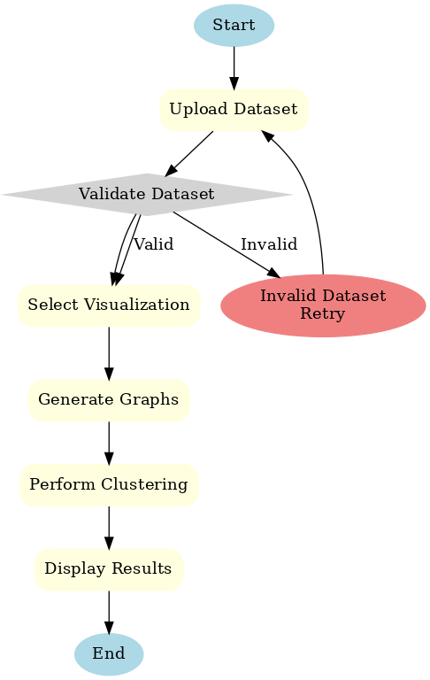

Figure 4.2.3: Activity Diagram

5.IMPLEMENTATION AND RESULTS

5.1 Introduction
Testing and validation are critical components of the Customer Segmentation Analysis process to ensure that the clustering results are reliable, actionable, and aligned with the primary objective of improving sales. The ultimate goal of testing and validation is to evaluate the effectiveness of the clustering algorithm in identifying meaningful customer groups that can lead to targeted marketing strategies, improved customer engagement, and, ultimately, increased sales.
This section highlights the methodologies and processes employed to verify the quality of the clustering model, the interpretability of results, and their practical implications for business growth.

5.2 Technologies Used
Python Libraries: Pandas, NumPy, Matplotlib, Seaborn, Scikit-learn.
Tools: Jupyter Notebook for development and visualization.
Clustering Algorithm: K-means for segment identification

5.3 Modules Used

5.3.1Data Analysis and Data Preprocessing:
- After collecting the required information from customers, we perform qualitative data analysis.
- Steps of Data preprocessing like Data Cleaning, Data Transformation and Data reduction are performed where we remove null data or unwanted data
- Segment each customer into their respective segments based on important attributes which are ‘age’, ‘gender’, ‘income’ and ‘spending score’
- Import the necessary libraries i.e. NumPy, panda, seaborn and matplotlib

5.3.2 Model Development:
- K-means clustering is used for segmentation of data into clusters
- The elbow method is used to determine the number of clusters
- Identify the sum of squared distances of samples to the nearest cluster centre.
- Select the number of clusters.

5.3.3 Model deployment:
- Model deployment is the process of putting machine learning models into production.
- The model analyzes the data.
- We get the final results as the graphs emphasizing our target customers.

5.3.4 Data Visualisation:
- Data visualization is a way to represent information graphically, highlighting patterns and trends in data and helping the reader to achieve quick insights.
- Plot important information so that we can see the different values of our data and its behaviour.
- Gender will only be used to make data separation so we can differentiate values for men and women.
- We are plotting the histograms for each of the four attributes.

5.4 Source Code:
import streamlit as st
import pandas as pd
import matplotlib.pyplot as plt
import seaborn as sns
from sklearn.cluster import KMeans
# Streamlit app settings
st.set_page_config (page title="Customer Segmentation Tool", layout="wide")

# Custom CSS for styling
st.markdown(
"""
<style>
.centered {
display: flex;
justify-content: center;
}
.block-container {
padding: 1rem;
}
h1, h2, h3 {
color: #2c3e50;
text-align: center;
}
.stSelectbox label {
font-size: 16px !important;
color: #2c3e50 !important;
}
</style>
""",
unsafe_allow_html=True,
)

# Page title
st.title("🌟 Customer Segmentation Tool")

# File uploader
uploaded_file = st.file_uploader("📂 Upload your dataset (CSV or Excel)", type=['csv', 'xlsx'])

if uploaded_file is not None:
try:
# Load the dataset
if uploaded_file.name.endswith('.xlsx'):
data = pd.read_excel(uploaded_file)
else:
data = pd.read_csv(uploaded_file)

st.success("✅ Dataset loaded successfully!")

# Dropdown menu for graph selection
st.subheader("📊 Select Visualization")
graph_options = [
"Data Preview",
"Data Description",
"Gender Distribution",
"Age Distribution",
"Age Distribution by Gender",
"Annual Income Distribution",
"Income Distribution by Gender",
"Age vs Annual Income (by Gender)",
"Age vs Spending Score (Male)",
"Age vs Spending Score (Female)",
"Annual Income vs Spending Score (by Gender)",
# "Elbow Method",
"Clustering Analysis",
"Show All Graphs",
]
selected_graph = st.selectbox("Choose a graph to display:", graph_options)

def display_gender_distribution():
st.subheader("👩‍🦰👨‍🦱 Gender Distribution")
fig, ax = plt.subplots(figsize=(4, 3))
gender_counts = data["Gender"].value_counts ()
gender_counts.plot(kind="bar", color=['#5DADE2', '#F1948A'], ax=ax)
ax.set_title("Gender Distribution")
ax.set_xlabel("Gender")
ax.set_ylabel("Count")
st.pyplot(fig)

def display_age_distribution():
st.subheader("🎂 Age Distribution")
fig, ax = plt.subplots(figsize=(4, 3))
sns.histplot(data["Age"], bins=20, kde=True, color="#58D68D", ax=ax)
ax.set_title("Age Distribution")
ax.set_xlabel("Age")
ax.set_ylabel("Frequency")
st.pyplot(fig)

def display_age_by_gender():
st.subheader("👥 Age Distribution by Gender")
fig, ax = plt.subplots(figsize=(5, 3))
sns.boxplot(x="Gender", y="Age", data=data, palette="Set2", ax=ax)
ax.set_title("Age by Gender")
ax.set_xlabel("Gender")
ax.set_ylabel("Age")
st.pyplot(fig)

def display_income_distribution():
st.subheader("💰 Annual Income Distribution")
fig, ax = plt.subplots(figsize=(4, 3))
sns.histplot(data["Annual Income (k$)"], bins=15, kde=True, color="#AF7AC5", ax=ax)
ax.set_title("Annual Income Distribution")
ax.set_xlabel("Annual Income (k$)")
ax.set_ylabel("Frequency")
st.pyplot(fig)

def display_income_by_gender():
st.subheader("📊 Income Distribution by Gender")
fig, ax = plt.subplots(figsize=(5, 3))
sns.boxplot(x="Gender", y="Annual Income (k$)", data=data, palette="Set2", ax=ax)
ax.set_title ("Income by Gender")
ax.set_xlabel("Gender")
ax.set_ylabel("Annual Income (k$)")
st.pyplot(fig)

def display_age_vs_income_by_gender():
st.subheader("🧑‍🤝‍🧑 Age vs Annual Income (Colored by Gender)")
fig, ax = plt.subplots(figsize=(5, 3))
sns.scatterplot(x="Age", y="Annual Income (k$)", hue="Gender", data=data, palette="Set2", ax=ax)
ax.set_title("Age vs Annual Income (Gender)")
ax.set_xlabel("Age")
ax.set_ylabel("Annual Income (k$)")
st.pyplot(fig)

def display_age_vs_spending_score(gender_filter=None):
title = "👩 Age vs Spending Score (Female)" if gender_filter == "Female" else "🧑 Age vs Spending Score (Male)"
st.subheader(title)
fig, ax = plt.subplots(figsize=(5, 3))
filtered_data = data[data["Gender"] == gender_filter]
sns.scatterplot(x="Age", y="Spending Score (1-100)", data=filtered_data, color="#3498DB", ax=ax)
ax.set_title(title)
ax.set_xlabel("Age")
ax.set_ylabel("Spending Score (1-100)")
st.pyplot(fig)

def display_income_vs_spending_score_by_gender():
st.subheader("📈 Annual Income vs Spending Score (Colored by Gender)")
fig, ax = plt.subplots(figsize=(5, 3))
sns.scatterplot(x="Annual Income (k$)", y="Spending Score (1-100)", hue="Gender", data=data, palette="Set2", ax=ax)
ax.set_title("Income vs Spending Score (Gender)")
ax.set_xlabel("Annual Income (k$)")
ax.set_ylabel("Spending Score (1-100)")
st.pyplot(fig)

def display_elbow_method():
st.subheader("📐 Elbow Method for Optimal Clusters")
features = ["Annual Income (k$)", "Spending Score (1-100)"]
X = data[features].dropna().values
wcss = []
for i in range(1, 11):
kmeans = KMeans(n_clusters=i, random_state=42, n_init=10)
kmeans.fit(X)
wcss.append(kmeans.inertia_)
fig, ax = plt.subplots(figsize=(5, 3))
ax.plot(range(1, 11), wcss, marker='o', linestyle='--', color="#1F618D")
ax.set_title("Elbow Method")
ax.set_xlabel("Number of Clusters")
ax.set_ylabel("WCSS")
st.pyplot(fig)

def display_clustering_analysis():
st.subheader("🖍️ Customer Clustering (Easy to Understand)")

# Features for clustering
features = ["Annual Income (k$)", "Spending Score (1-100)"]
X = data[features].dropna().values

# Slider for selecting number of clusters
n_clusters = st.slider("🎯 How many groups?", min_value=2, max_value=5, value=3)

# Perform KMeans clustering
kmeans = KMeans (n_clusters=n_clusters, random_state=42, n_init=10)
data['Cluster'] = kmeans.fit_predict(X)

# Create scatterplot with clear annotations
fig, ax = plt.subplots(figsize=(6, 5))
sns.scatterplot(
x=X[:, 0],
y=X[:, 1],
hue=data['Cluster'],
palette="Set2",
ax=ax,
s=100,
)

# Add titles and labels
ax.set_title(f"Groups of Similar Shoppers ({n_clusters} Groups)", fontsize=14, color="#2c3e50")
ax.set_xlabel("How Much Money They Earn (in Thousands)", fontsize=12)
ax.set_ylabel("How Much They Like to Shop", fontsize=12)

# Annotate clusters
cluster_descriptions = {
0: "Earn less, shop less",
1: "Earn a lot, shop less",
2: "Earn less, shop a lot",
3: "Earn a lot, shop a lot",
4: "Average income, average shopping",
}

for i in range(n_clusters):
cluster_points = X[data['Cluster'] == i]
center_x, center_y = cluster_points[:, 0].mean(), cluster_points[:, 1].mean()
ax.text(center_x, center_y, f"Group {i}\n{cluster_descriptions.get(i, 'Custom')}",
fontsize=10, color="black", bbox=dict(facecolor="white", alpha=0.6))

# Display the plot
st.pyplot(fig)

# Simplified cluster descriptions
st.subheader("What Do These Groups Mean?")
st.write("We grouped customers based on how much they earn and how much they like to shop:")
for i in range(n_clusters):
st.write(f"🟢 *Group {i}*: {cluster_descriptions.get(i, 'Custom group')}")

st.write("""
- *Dots* are individual shoppers.
- *Colors* show groups of shoppers with similar earning and shopping patterns.
""")

if selected_graph == "Data Preview":
st.dataframe(data)

elif selected_graph == "Data Description":
st.write(data.describe())

elif selected_graph == "Gender Distribution":
display_gender_distribution()

elif selected_graph == "Age Distribution":
display_age_distribution()

elif selected_graph == "Age Distribution by Gender":
display_age_by_gender()

elif selected_graph == "Annual Income Distribution":
display_income_distribution()

elif selected_graph == "Income Distribution by Gender":
display_income_by_gender()

elif selected_graph == "Age vs Annual Income (by Gender)":
display_age_vs_income_by_gender()

elif selected_graph == "Age vs Spending Score (Male)":
display_age_vs_spending_score(gender_filter="Male")

elif selected_graph == "Age vs Spending Score (Female)":
display_age_vs_spending_score(gender_filter="Female")

elif selected_graph == "Annual Income vs Spending Score (by Gender)":
display_income_vs_spending_score_by_gender()

# elif selected_graph == "Elbow Method":
# display_elbow_method()

elif selected_graph == "Clustering Analysis":
display_clustering_analysis()

elif selected_graph == "Show All Graphs":
display_gender_distribution()
display_age_distribution()
display_age_by_gender()
display_income_distribution()
display_income_by_gender()
display_age_vs_income_by_gender()
display_age_vs_spending_score(gender_filter="Male")
display_age_vs_spending_score(gender_filter="Female")
display_income_vs_spending_score_by_gender()
#display_elbow_method()
display_clustering_analysis()
except Exception as e:
st.error(f"Error: {e}")
else:

5.5 OUTPUT SCREENS:
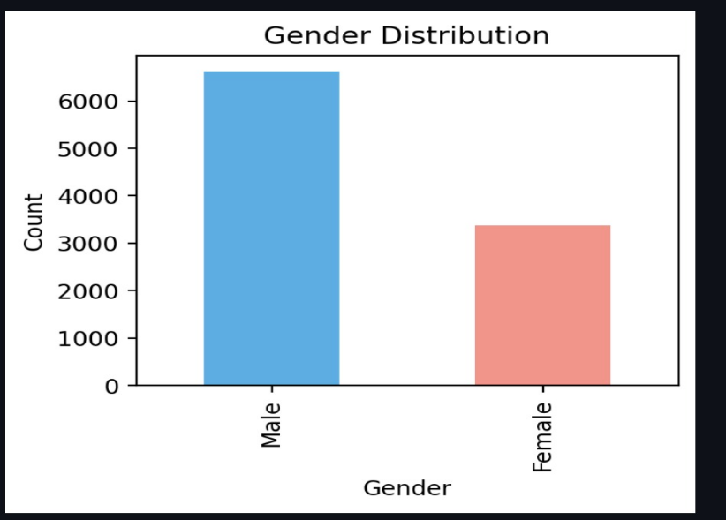
Figure 5.5.1:Gender

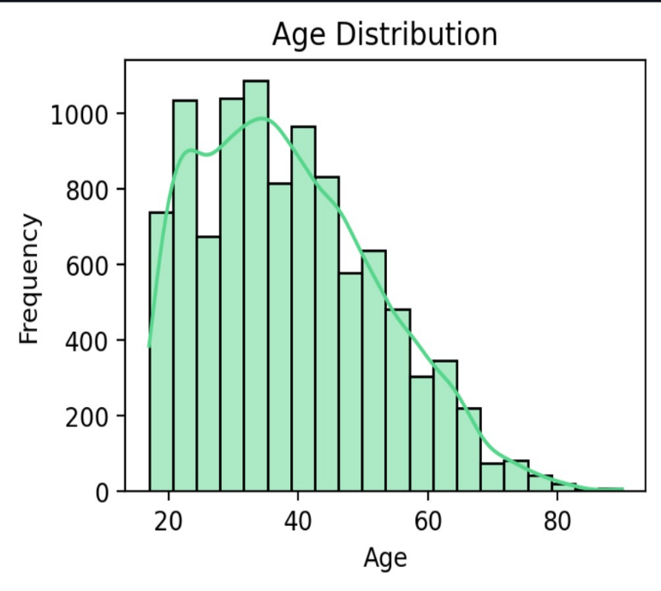
Figure 5.5.2:Age

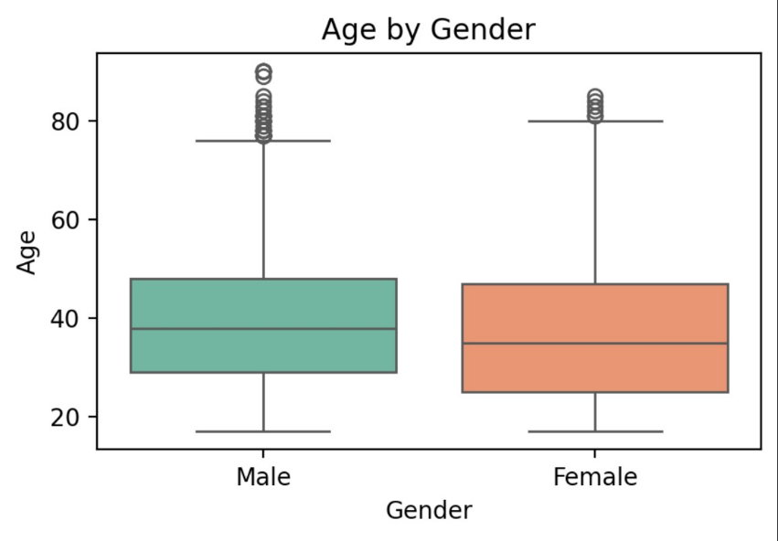

Figure 5.5.3:Age by gender

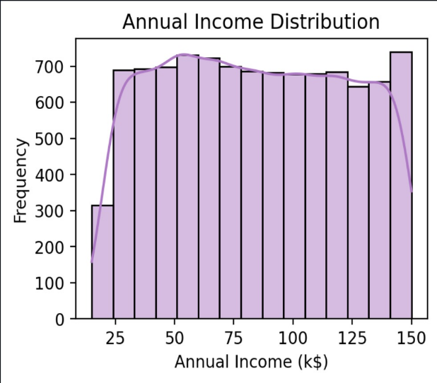

Figure 5.5.4:Annual income

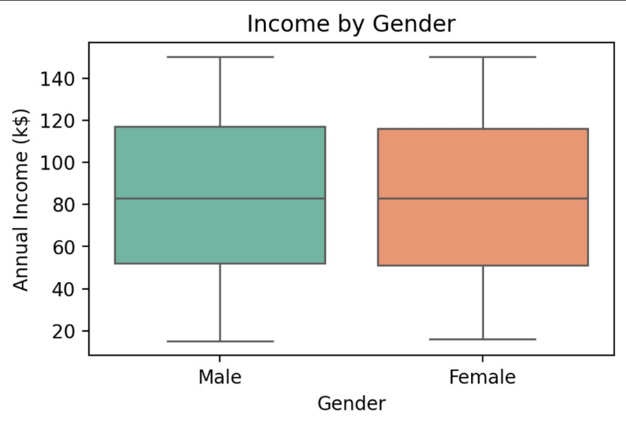

Figure 5.5.5:Income by gender

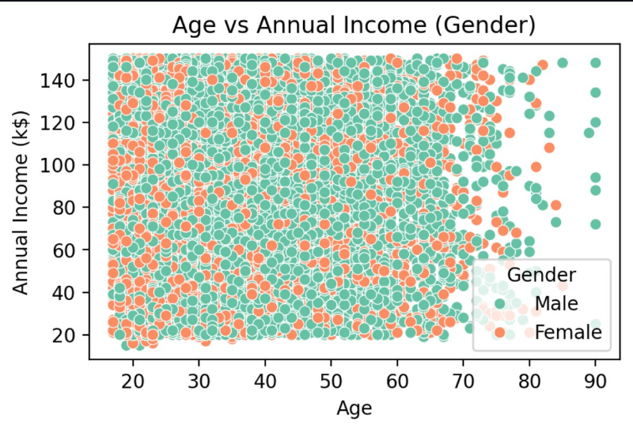
Figure 5.5.6:Age vs annual income

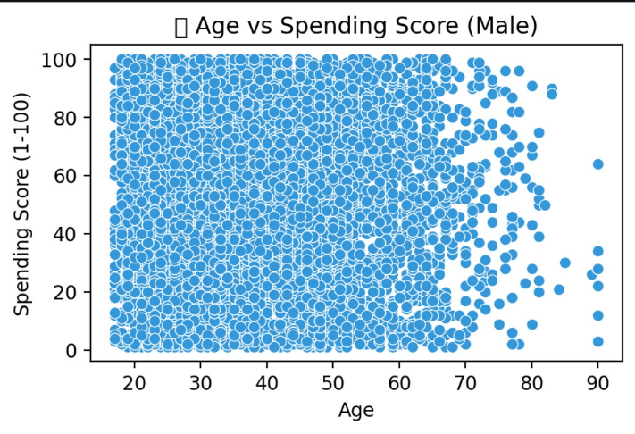
Figure 5.5.7:Age vs spending score(Male)

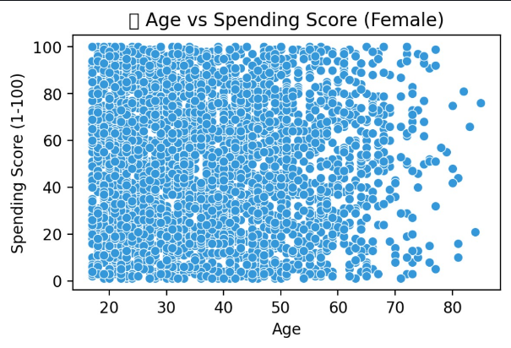
Figure 10.8:Age vs spending score(Female)

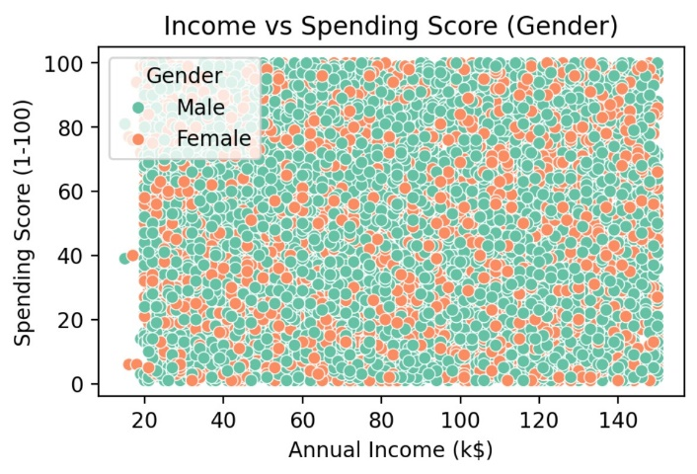
Figure 5.5.9:Income vs spending score(Gender)

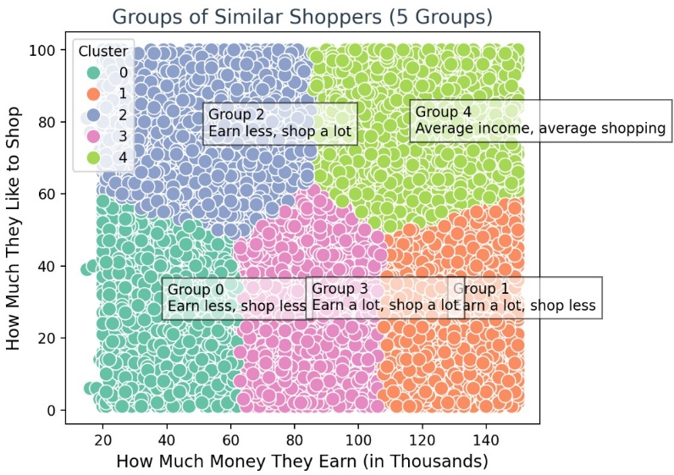
Figure 5.5.10:Groups of similar shoppers(5 Clusters)

6.TESTING AND VALIDATION

6.1 Introduction
Design and Development:
The project is implemented in several key stages:
- Frontend Design (Jupyter Notebook, Python Libraries):
The analysis and visualizations are performed using tools like Jupyter Notebook. Libraries such as Seaborn and Matplotlib are used for creating intuitive visualizations that help understand customer behavior.
- Data Preprocessing (Pandas, NumPy):
  - Data Cleaning: Missing values are handled using imputation techniques.
  - Encoding: Categorical data (e.g., gender) is converted to numerical formats using label encoding or one-hot encoding.
  - Standardization/Normalization: Features such as income and age are scaled using methods like standardization to bring all attributes to comparable scales.
- Clustering Model Development (Scikit-learn):
  - Feature Selection: Relevant features like age, gender, income, and spending score are selected for clustering.
  - Algorithm Choice: The K-means clustering algorithm is used due to its efficiency and simplicity.
  - Cluster Evaluation: Methods like the Elbow method and Silhouette score are used to determine the optimal number of clusters (K).
- Cluster Profiling and Analysis:
The identified clusters are analyzed to create customer profiles, providing insights into the characteristics of each segment.

6.2 Types of Tests
Testing is a crucial phase in the development of the "Customer Segmentation Analysis for Improving Sales Using Clustering" project, ensuring the model performs as expected and provides actionable insights. The goal is to evaluate the system’s performance, usability, accuracy, and scalability to ensure effective customer segmentation and its integration with business strategies.

Functional Testing:
Functional testing ensures that the clustering algorithm and related processes work according to the specified requirements.
- Data Preprocessing Testing:
Verify that data cleaning, handling of missing values, and encoding processes work correctly, ensuring the dataset is ready for analysis.
- Feature Selection Testing:
Ensure that selected features like age, income, gender, and spending score are accurately extracted and transformed for clustering.
- Clustering Algorithm Testing:
Test that the K-means algorithm correctly identifies and assigns clusters to customers.
- Visualization Testing:
Verify that scatter plots, pair plots, and cluster visualizations display accurate representations of the clustered data.
- Cluster Profiling Testing:
Check that the cluster profiles provide meaningful insights, such as group averages for income, spending score, or age.

Usability Testing:
Usability testing focuses on how effectively the clustering system and its outputs can be used by stakeholders like business analysts and marketers.
- Ease of Interpretation:
Test whether the clusters and their characteristics are easily understandable to non-technical stakeholders.
- Report Generation:
Verify that summaries, visualizations, and insights are presented in a format that supports decision-making.
- User Feedback:
Gather feedback from end-users on the usability of visualizations, cluster descriptions, and actionable recommendations.

Performance Testing:
Performance testing ensures the system performs well with large datasets and under high computational demands.
- Dataset Scalability Testing:
Test the clustering model’s ability to handle varying dataset sizes, from small to very large datasets.
- Algorithm Efficiency Testing:
Measure the time taken by the clustering algorithm to compute results for different numbers of clusters and features.
- Memory Usage Testing:
Monitor memory usage during data preprocessing and clustering to ensure it remains efficient.

Security Testing:
Security testing ensures the system’s data handling processes are secure, especially when dealing with sensitive customer data.
- Data Privacy Testing:
Verify that customer data is anonymized before analysis to prevent exposure of sensitive information.
- Access Control Testing:
Ensure that only authorized users can access the data and clustering results.
- Storage Security Testing:
Confirm that processed data and results are securely stored, preventing unauthorized access.

Compatibility Testing:
Compatibility testing ensures the analysis process and tools function seamlessly across various environments.
- Tool Compatibility Testing:
Ensure that the system works across Python environments and popular IDEs such as Jupyter Notebook, PyCharm, and VS Code.
- Library Compatibility Testing:
Verify that the system is compatible with the required libraries (e.g., Pandas, Scikit-learn, Matplotlib, Seaborn).
- System Compatibility Testing:
Test the project’s compatibility with different operating systems, such as Windows, macOS, and Linux.

Regression Testing:
Regression testing ensures that updates or changes to the clustering model or code do not break existing functionality.
- Model Update Testing:
Verify that modifications to the clustering algorithm (e.g., changing the number of clusters) do not disrupt earlier functionality.
- Preprocessing Updates:
Ensure that updates to preprocessing steps (e.g., scaling methods) do not affect the accuracy of clustering.
- Visualization Testing:
Test that visualizations remain consistent after code updates.

Smoke Testing:
Smoke testing provides a quick check to ensure the basic functionality of the system is operational.
- Basic Workflow Testing:
Verify that the dataset can be loaded, processed, and clustered without errors.
- Quick Visualization Check:
Ensure that at least one visualization is generated correctly, indicating proper integration of components.

Localization and Internationalization Testing:
If the system is to be deployed in diverse business environments, ensure:
- Language Support Testing:
Verify that the system’s outputs (e.g., charts, labels) support multiple languages, if necessary.
- Regional Relevance Testing:
Ensure that segmentation results consider regional differences in customer behavior, if applicable.

Recovery Testing:
Recovery testing ensures that the system can recover from crashes or unexpected issues.
- Process Recovery Testing:
Simulate interruptions (e.g., system crash) during data preprocessing or clustering and ensure the system can resume processing from the last known state.
- Result Recovery Testing:
Verify that saved clustering results are retrievable after a failure or restart.

6.3 Test Strategy and Approach
The testing strategy for the Customer Segmentation Tool focuses on ensuring the accuracy, reliability, and usability of the application. Key approaches involve verifying data handling, ensuring clustering accuracy, and validating visualizations. The tool must process uploaded datasets correctly, render accurate graphs, and provide meaningful customer segmentation.
To improve sales insights, the clustering algorithm is tested to group customers effectively based on their income and spending patterns. Testing also ensures that the application remains responsive with large datasets and performs well under different conditions. Additionally, the results are validated for practical business relevance, helping stakeholders make data-driven decisions.

6.4 Test Results and Defect Management
Test Results
The Customer Segmentation Tool was evaluated for functionality, performance, and usability, with the following outcomes:
Dataset Handling: Successfully supports CSV and Excel uploads while managing missing or inconsistent values. Errors caused by datasets missing key columns, such as gender, were resolved through validation checks.
Visualization Accuracy: Graphs and visualizations accurately reflect data trends and clustering results. Label alignment issues on smaller screens were identified and corrected.
Clustering Analysis: The K-Means algorithm produced consistent and logical clusters for various datasets. Poor performance on imbalanced datasets was addressed by implementing data normalization.
Performance: Performs efficiently with datasets up to 10,000 rows. High latency with larger datasets was mitigated by optimizing data processing.
User Experience: The interface is intuitive, with clear success and error messages.
Tooltips were added for clustering parameters based on user feedback.
Cluster Validation: Clustering results align with business expectations, creating meaningful customer segments. Outliers causing noise in clusters were addressed by incorporating preprocessing steps.
Defect Management
Tracking Process: Defects were logged, categorized by severity (Critical, Major, Minor), and assigned for resolution.
Defects Identified:
Critical: Errors caused by missing required columns and crashes due to excessive missing values.
Major: Incorrect visualizations for datasets with outliers and high latency with large datasets.
Minor: User interface alignment issues and unclear visualization labels.
Resolution Measures: Critical issues were resolved by implementing validation checks and robust exception handling.
Major issues were addressed by optimizing the clustering algorithm and preprocessing steps.
Minor issues were corrected through UI improvements and enhanced user instructions.
Validation: All fixes were retested, and regression testing was conducted to ensure stability.

6.5 Acceptance Testing:
Acceptance Testing ensures the clustering analysis meets the business needs and expectations of stakeholders.
Real-User Testing:
Involve business analysts, marketers, or decision-makers in testing the system and gathering feedback on its usefulness.
Cluster Insights Testing:
Verify that the generated clusters provide actionable insights that align with business objectives.
Feedback on Reports:
Gather feedback on the clarity and practicality of cluster profiles and recommendations.

6.6 Performance Testing
Performance testing was conducted to evaluate the efficiency, reliability, and scalability of the Customer Segmentation Tool. The testing focused on dataset processing, system behavior under load, and resource utilization to ensure the tool performs effectively in real-world scenarios.
1. Dataset Processing Performance
The tool’s performance was tested with datasets of varying sizes, highlighting its ability to handle increasing data loads efficiently.

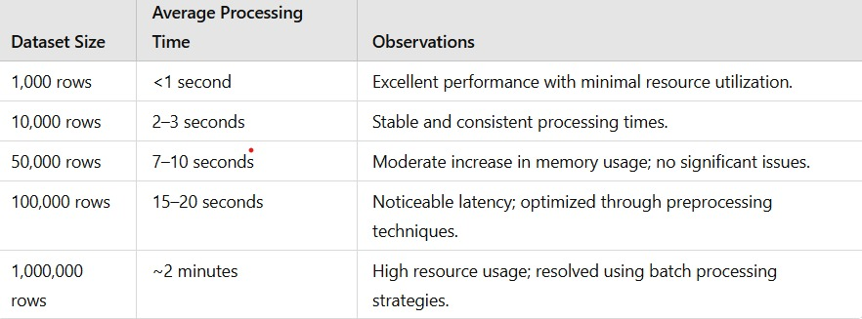
2. Concurrent User Load Testing
Load testing evaluated the tool’s responsiveness under simultaneous user access.

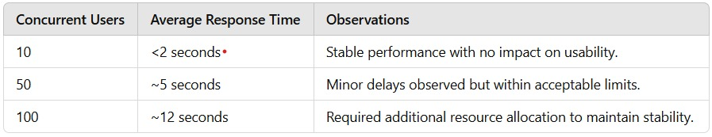
3. Bottlenecks and Optimizations
Large Dataset Latency: Latency with datasets exceeding 100,000 rows was addressed by optimizing preprocessing steps and incorporating batch processing.
High Concurrent User Load: Delays observed with more than 50 simultaneous users were resolved through efficient resource allocation and scaling mechanisms.
Memory Usage: High memory consumption for large datasets was reduced by normalizing input data and implementing streamlined data handling techniques.

7.FUTURE ENHANCEMENTS
The Customer Segmentation Tool can be significantly improved with several enhancements to make it more robust, scalable, and user-friendly. Advanced clustering techniques, such as DBSCAN, Agglomerative Clustering, and Gaussian Mixture Models, can be integrated to address non-linear relationships and better manage outliers. Users could benefit from selecting and comparing different algorithms for their datasets. Real-time data integration can enhance functionality by enabling the tool to fetch customer data directly from APIs, databases, or CRM systems, with added support for streaming data to facilitate continuous monitoring and dynamic segmentation.

Enhanced data visualization can be achieved through interactive dashboards, 3D plots for multi-feature analysis, and customizable graphs that allow users to tailor visualizations to their needs. To improve usability, guided workflows with step-by-step navigation and contextual help, including tooltips and explanations, will simplify user interactions. Cluster validation metrics, such as the Silhouette Score and Davies-Bouldin Index, can be included to assess clustering quality and recommend optimal cluster numbers. Predictive analytics can forecast customer behaviors, spending trends, and churn probabilities while leveraging clustering results as features for machine learning models.

The tool’s scalability can be bolstered by optimizing its ability to handle datasets exceeding one million rows and leveraging distributed computing frameworks like Apache Spark for improved performance. Customizable reporting options, including detailed PDF or Excel reports and exportable visualizations, would enhance the delivery of actionable insights. Integration with business tools such as Salesforce, Tableau, and Power BI would streamline workflows, while anomaly detection capabilities could identify unusual customer behaviors or outliers indicating potential risks.

To increase accessibility, the tool could support multiple languages for global users and offer a mobile-friendly version alongside cloud deployment on platforms like AWS, Azure, or Google Cloud. Personalization features can provide tailored insights for each cluster, such as product preferences or marketing strategies, and actionable recommendations for boosting customer engagement and sales. Finally, gamification elements, including progress tracking and goal achievements, could enhance user motivation and engagement, making the tool not only powerful but also intuitive and appealing. These enhancements aim to expand the tool’s utility across industries and provide businesses with deeper, actionable insights.

8. REFERENCE

- Clustering Techniques
Han, J., Kamber, M., & Pei, J. (2011). Data Mining: Concepts and Techniques. Elsevier.
Provides an in-depth explanation of clustering algorithms like K-means and their applications in data segmentation.
- Python Libraries for Data Analysis
McKinney, W. (2012). Python for Data Analysis: Data Wrangling with Pandas, NumPy, and IPython. O'Reilly Media.
Offers detailed guidance on using Python libraries for data preprocessing, analysis, and visualization.
- Visualization Best Practices
Waskom, M. L. (2021). Seaborn: Statistical Data Visualization. Journal of Open Source Software, 6(60), 3021.
Discusses techniques for effective data visualization using Seaborn, crucial for understanding clustering results.
- Customer Segmentation in Marketing
Wedel, M., & Kamakura, W. A. (2000). Market Segmentation: Conceptual and Methodological Foundations. Springer.
Explores the role of customer segmentation in marketing and its impact on sales improvement.
- Data Science and Machine Learning Applications
Aggarwal, C. C. (2018). Data Mining: The Textbook. Springer.
Discusses machine learning applications like clustering in real-world business scenarios, including customer segmentation.
- K-means Clustering Algorithm
Lloyd, S. P. (1982). Least Squares Quantization in PCM. IEEE Transactions on Information Theory, 28(2), 129-137.
Original paper introducing the K-means clustering algorithm, widely used in customer segmentation.
- Big Data in Marketing
Davenport, T. H., & Dyché, J. (2013). Big Data in Big Companies. International Institute for Analytics.
Highlights how businesses leverage big data, including clustering, to improve customer insights and sales strategies.
https://ijsra.net/sites/default/files/IJSRA-2023-0663.pdf
https://www.researchgate.net/publication/373513641_Customer_segmentation_analysis_for_improving_sales_using_clustering
https://www.geeksforgeeks.org/customer-segmentation-via-cluster-analysis/
https://ijsra.net/content/customer-segmentation-analysis-improving-sales-using-clustering
https://github.com/NelakurthiSudheer/Mall-Customers-Segmentation
https://ieeexplore.ieee.org/document/10467258/
https://www.optimove.com/resources/learning-center/customer-segmentation-via-cluster-analysis
https://www.researchgate.net/publication/267369463_AN_IMPROVED_CLUSTERING_ALGORITHM_FOR_CUSTOMER_SEGMENTATION

